Chapter 3, Problem 44.

Use mesh analysis to obtain i_{o} in the circuit of Fig. 3.90.

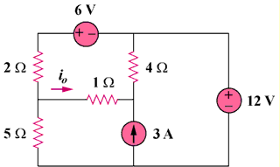

90 V

180 V

45 A

Figure 3.90
For Prob. 3.44.

